Modeling Data in Excel
HODROJ Samer
201100607
Section 6
Thursday, December 23, 2010

REPORT GRADING

Expected Features
1. Title Page: everything centered including title, name, date, etc. | /6
2. Typed Report using proper structure (“Sandwich” presentation and  References): Introduction followed by Work Description followed by Conclusion followed by References | /6
3. Professionalism: spacing, 11- or 12-point font, grammar, spelling,  punctuation, language, consistency, writing tips followed | /13
4. Introduction: motivation and objectives of work, overview, report  organization | /8
5. Modeling process description (Work Description/Modeling Process) | /8
6. Cone equations (MathType) | /8
7. List of useful Excel tools (Work Description/Tools) | /8
8. Graphs - graph placed in a figure similar to Figure 1 (Work  Description/ Results) | /8
9. Excel spreadsheet with graph and formulas (Work Description/Results) | /13
10. Discussion of results (Work Description/Results) | /8
11. Conclusion | /8
12. References – find and cite at least 3 references related to this  assignment. | /6
TOTAL SCORE | /100

Introduction:
In this report, I will talk about mathematical models and how to develop them using a spreadsheet or even using mathtype in writing and formulating any equation. In special, I’ll talk about how we could compute the different measures of a cone (radius, volume, area) and display the results on a graph or even express the formulas with mathtype.

This report is represented as following:
- Introduction: ▪ Outline
- Work Description: ▪ Modeling Process: Definition & Useful equations of cones.
▪ Discuss typical types of applications.
▪ Tools subsection: Useful Excel tools
▪ Results: Discuss the results and illustrate them through graphs.
- Conclusion
- References

Work Description:
Definition & Useful equations of cones:
A cone is a geometric shape that goes from a flat circular base to a point called the apex or vertex. The axis of a cone is the straight line (if any), passing through the apex, about which the lateral surface has a rotational symmetry.
In common usage in elementary geometry, cones are assumed to be right circular, where right means that the axis passes through the centre of the base (suitably defined) at right angles to its plane, and circular means that the base is a circle.
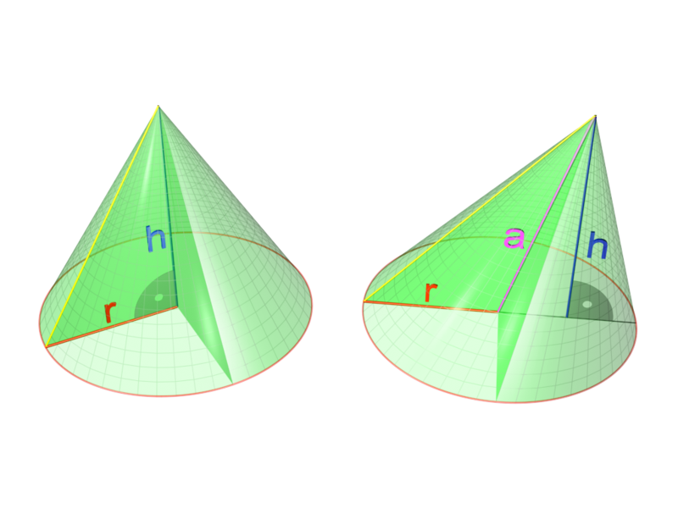
In general, however, the base may have any different shape, and the apex may lie anywhere (though it is often assumed that the base is bounded and has nonzero area, and that the apex lies outside the plane of the base). For example, a pyramid is technically a cone with a polygonal base.

Let’s take a cone with “h” its height, “r” its radius oriented in the positive direction of Z axis, the vertex pointed up, and its base on z=0.
Using Mathtype on the Microsoft Word Office, we can establish its parameter equations:
for and.
is the vertex angle made by a cross section through the apex and center of the base. For a cone of height "h" and radius "r", it is given by
The volume of a cone is expressed by:
Since the base area is a circle, again we can substitute the area formula for a circle into the volume formula, in place of the base area. The final formula for the volume of a cone is:

The total surface area "T" is given by the following formula:
With "s" = slant height:
Typical types of applications:
Three types of information can be entered into the Excel cell: text, data, and formulas.
Excel will automatically interpret what the user types and select the appropriate category for the
information. For example, if what he begins typing with a letter of the alphabet, it
automatically becomes Text. Alternatively, if the information begins with an equals sign (=),
Excel automatically assumes that the information is a formula.
Text that has been entered into a cell may need to be corrected or erased. The simplest
way to correct the entry, if the text is not lengthy or complicated, is to retype it. To do this, select
the cell you wish to edit. The old text will appear in the Function Bar. Typing will overwrite
the old text.
Another way to edit text is to make correction on the Function Bar. We select the cell in
question. Move the mouse’s pointer to the point in the text in the Function Bar where you wish
to edit (the cursor symbol will turn into the I-beam).
Useful Excel Tools:
First, we have to enter the needed data in cells. We'll have a table where we can examine the volume and the area of the cone depending on his radius. The height of the cone is fixed (it is equal to 20 centimeter).
The radius is variable. We don't have to enter each value every time: we can do it in a simpler way using relative and absolute addresses. Excel’s formula copying feature has an updating capability which will enter the appropriate formula into the cells below. This is the relative address feature of Excel.
Absolute addresses are used for data in general and for design variables or parameters in particular.
Excel updates all relative addresses and not just the one we are interested. To make the increment address fixed, we need to assign it an absolute address in the formula. Absolute addresses are defined by the use of a dollar sign preceding the address. To specify the absolute column, you would put $ in front of the letter corresponding to the column. To specify the absolute row, you would put $ in front of the number of the row.
We should enter the following formulas of volume and area in the formula bar:
The volume: = (1/3)*pi ()*B7*F7^2
The area: =pi ()*F7*($B$7^2+F7^2) ^0.5
We need to copy cells through the different columns of radius, volume and area.
Second, we have to build a chart showing the evaluation of the volume and the area of the cone with the different values of radius.
We should insert the chart, give it a title, name the three different axes, and add a legend to differentiate the two graphs

Results:
After filling all the cells with the appropriate values, we will have as a result a chart with two graphs representing the variation of the volume and the area of a cone in function of its radius as table showing also the volume and the area and the radius of a cone with a constant height.

NASA Cone Design Problem |  |  | Samer Hodroj: Section 6
 |  |  | Cone | Cone | Cone
Design |  |  | Radius | Volume | Area
Variables |  |  | (cm) | (cc) | (sqcm)
Height(cm) | 20 |  | =B8 | =(1/3)*PI()*$B$7*F7^2 | =PI()*F7*($B$7^2+F7^2)^0.5
Radius(cm) | 5 |  | =F7+Increment | =(1/3)*PI()*$B$7*F8^2 | =PI()*F8*($B$7^2+F8^2)^0.5
Radius Inc. | 2 |  | =F8+Increment | =(1/3)*PI()*$B$7*F9^2 | =PI()*F9*($B$7^2+F9^2)^0.5
 |  |  | =F9+Increment | =(1/3)*PI()*$B$7*F10^2 | =PI()*F10*($B$7^2+F10^2)^0.5
 |  |  | =F10+Increment | =(1/3)*PI()*$B$7*F11^2 | =PI()*F11*($B$7^2+F11^2)^0.5
 |  |  | =F11+Increment | =(1/3)*PI()*$B$7*F12^2 | =PI()*F12*($B$7^2+F12^2)^0.5
 |  |  | =F12+Increment | =(1/3)*PI()*$B$7*F13^2 | =PI()*F13*($B$7^2+F13^2)^0.5
 |  |  | =F13+Increment | =(1/3)*PI()*$B$7*F14^2 | =PI()*F14*($B$7^2+F14^2)^0.5
 |  |  | =F14+Increment | =(1/3)*PI()*$B$7*F15^2 | =PI()*F15*($B$7^2+F15^2)^0.5
 |  |  | =F15+Increment | =(1/3)*PI()*$B$7*F16^2 | =PI()*F16*($B$7^2+F16^2)^0.5

Conclusion:

As the radius increases, the volume and the area of the cone increase also. They are related proportionally to the radius.
The Excel gave us a simple way to notice these variability and relations.

References:
- www.wikepedia.com
- www.mathforum.org
- www.mathworld.wolfram.com

